AI FAQ Assistant API
Project Demonstration Report
Project Demonstration Phase

Project Name | AI FAQ Assistant API
Team ID | SWTID-2026-9625
Date | 26 September 2026

1. Demonstration Objective
The objective of the project demonstration is to demonstrate the working functionality of the AI FAQ Assistant API and show how the different backend modules operate together.
The demonstration covers user authentication, JWT-based protected access, role-based authorization, FAQ management, category management, feedback, Google Gemini AI integration, keyword-based FAQ search, and AI-assisted answer generation.
The current project is implemented as a backend API using Express.js and MongoDB. The demonstration therefore focuses on API requests, responses, middleware protection, database operations, and AI service integration.

2. Demonstration Environment
The demonstration is performed using:
• Visual Studio Code
• Node.js
• Express.js
• MongoDB Atlas
• Google Gemini AI
• Thunder Client / API client
The backend is accessed through:
http://localhost:5000
The project uses environment variables for database, JWT, and Gemini configuration. Confidential values are not included in this report.
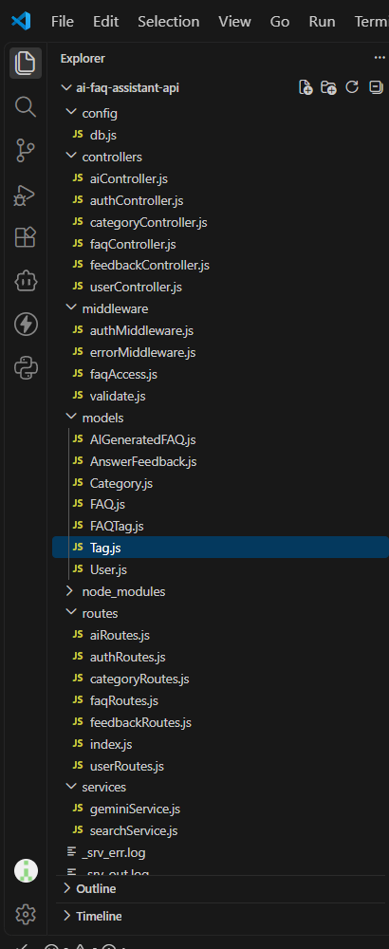
Figure 1. AI FAQ Assistant API project structure showing controllers, models, middleware, routes, services, and configuration files.

3. Demonstration Flow
The project is demonstrated in the following sequence:
• Start the Express.js backend and verify the health endpoint.
• Register and authenticate a user.
• Use the JWT token to access protected APIs.
• Demonstrate role-based access for admin and content creator operations.
• Create, retrieve, update, delete, and search FAQ records.
• Create and retrieve categories.
• Submit FAQ feedback.
• Generate an FAQ using Google Gemini.
• Save an AI-generated FAQ and request an AI-assisted answer.
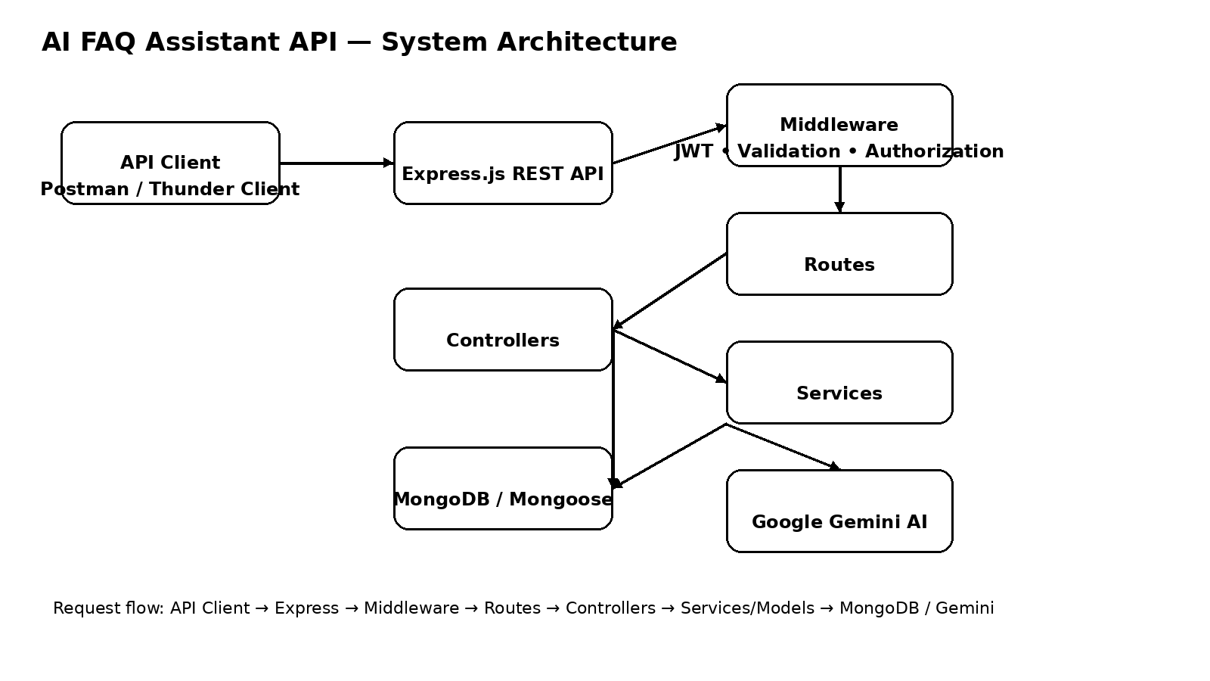
Figure 2. System architecture showing client requests, Express API, middleware, controllers, services, MongoDB, and Gemini AI integration.

4. Backend Startup
The backend server is started and the API is made available for testing. The application connects to MongoDB before starting the HTTP server.
The health-check endpoint is used to verify that the application is running successfully.
GET /health
The root endpoint also provides API status information:
GET /
The project uses port 5000 by default.
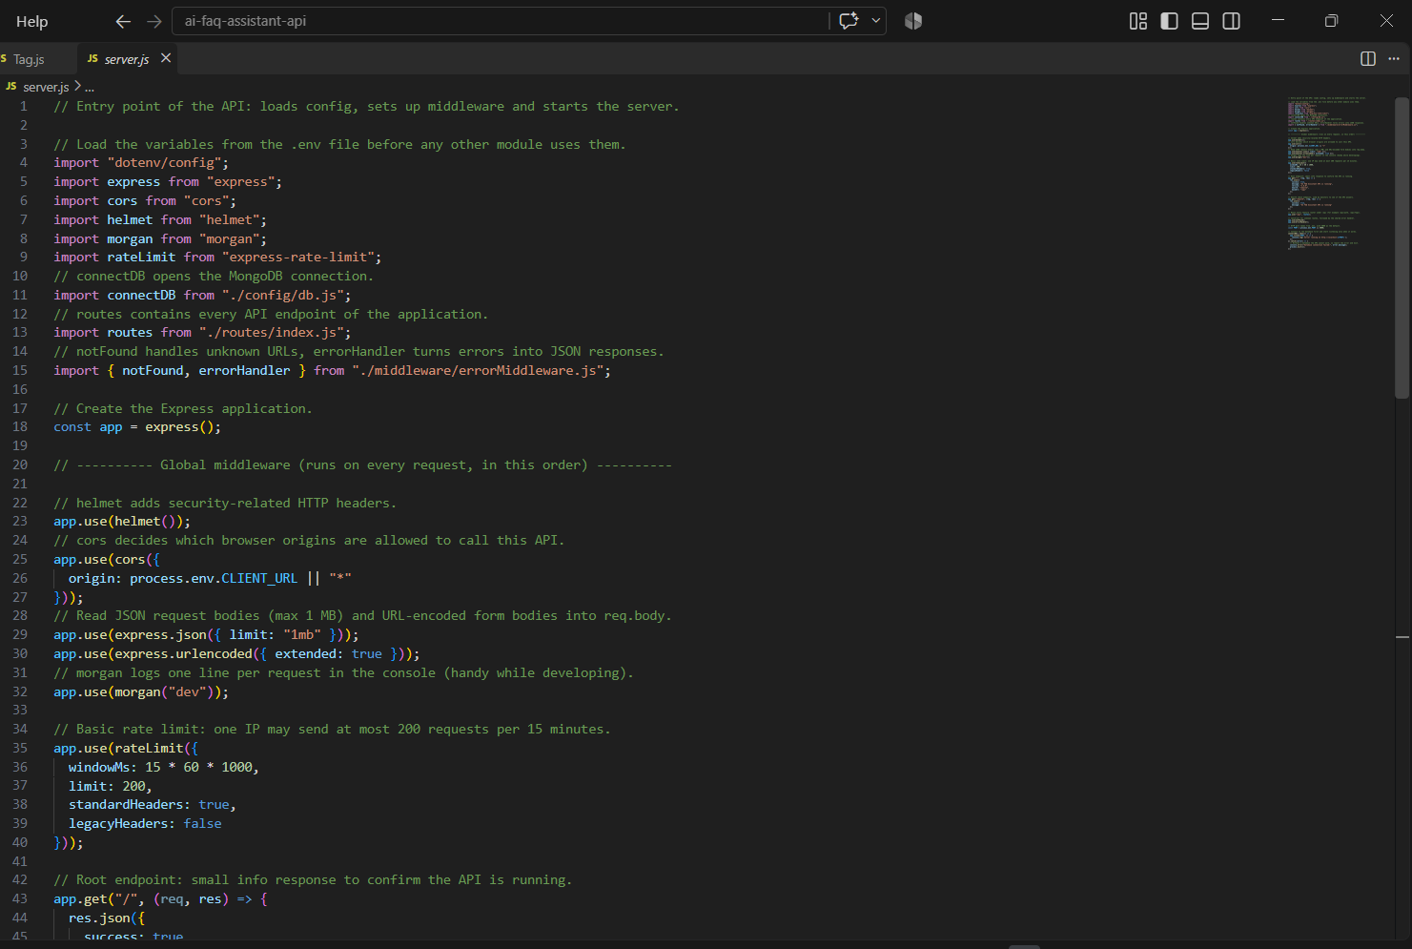
Figure 3. server.js showing Express configuration, middleware, rate limiting, route mounting, health endpoint, and server startup.
5. Authentication Demonstration
The registration API is demonstrated first.
POST /api/auth/register
A new user is created using valid registration details. Passwords are stored securely using bcrypt hashing in the User model.
Next, the login API is demonstrated:
POST /api/auth/login
After successful authentication, a JWT token is returned. The token is then supplied as a Bearer token when accessing protected APIs.
The profile API confirms the authenticated user:
GET /api/auth/profile
Actual passwords and JWT tokens are intentionally excluded from this report.
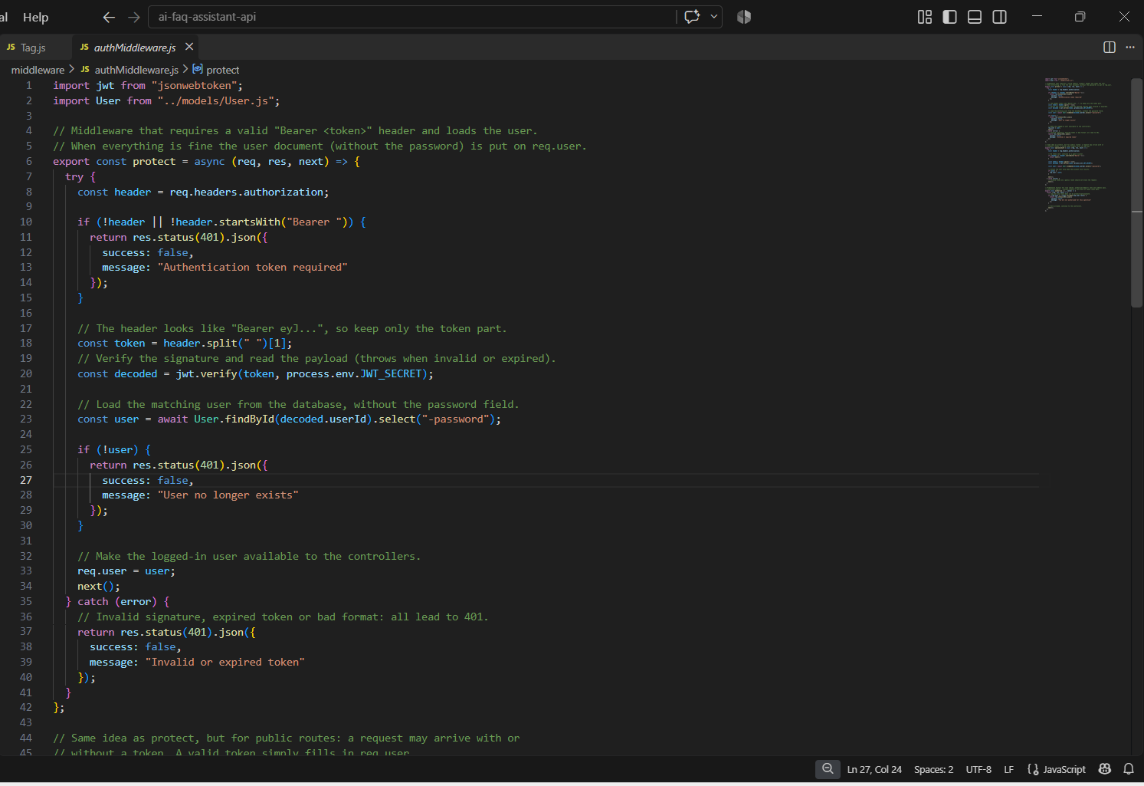
Figure 4. Authentication middleware and controller logic showing Bearer-token verification and protected user access.

6. Role-Based Access Control Demonstration
The project supports the following user roles:
• Admin
• Content Creator
• User
The demonstration shows that different users have different permissions. For example:
• An Admin can manage users, categories, and system-level resources.
• A Content Creator can create and manage FAQ content and use the AI FAQ generation features.
• A User can access public FAQ content, search FAQs, submit feedback, and use the protected AI answer feature.
The implementation uses authentication middleware, role authorization, and FAQ ownership protection.
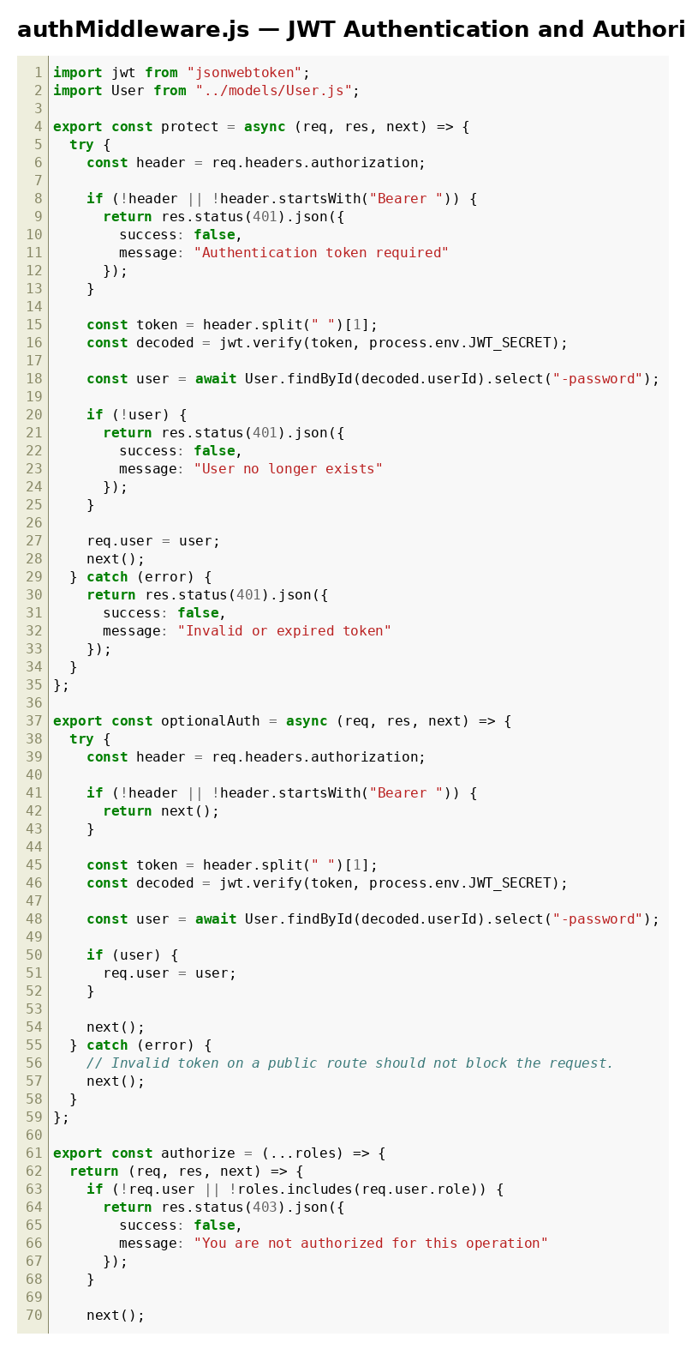
Figure 5. Authentication and authorization middleware used before protected operations.

7. FAQ Management Demonstration
The FAQ management APIs are demonstrated using an API client.
POST /api/faqs
GET /api/faqs
GET /api/faqs/:id
GET /api/faqs/mine
PUT /api/faqs/:id
DELETE /api/faqs/:id
The demonstration shows FAQ creation, retrieval, modification, deletion, ownership protection, visibility control, and view counting. Administrators can manage all FAQ records, while content creators are protected by ownership rules for their own FAQ records.
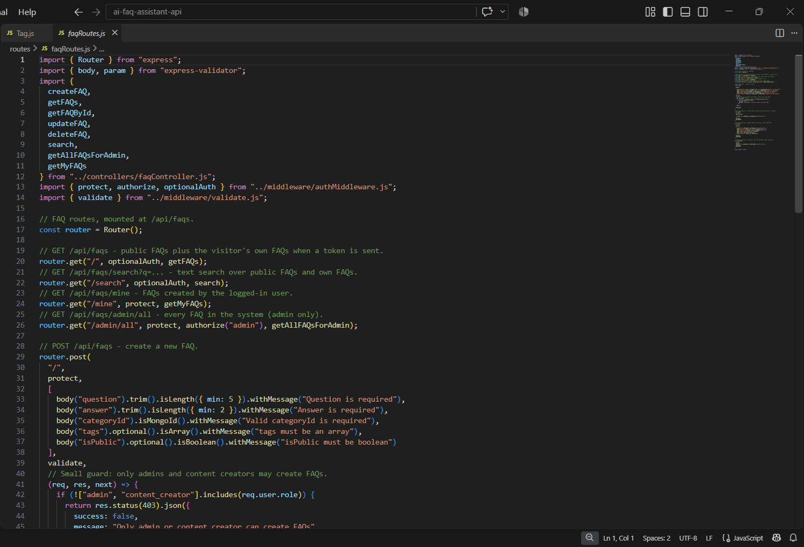
Figure 6. FAQ routes showing public retrieval, protected creation, ownership-controlled update/delete, and administrator operations.

8. Category and Feedback Demonstration
The category APIs are used to organize FAQ content.
GET /api/categories
POST /api/categories
PUT /api/categories/:id
DELETE /api/categories/:id
Category creation, update, and deletion are restricted to administrators.
The feedback API allows an authenticated user to submit feedback for an FAQ.
POST /api/feedback
Feedback contains the FAQ reference, a helpful/not-helpful value, and an optional comment. Administrators can retrieve feedback records.
GET /api/feedback
9. AI FAQ Generation Demonstration
Google Gemini is used to generate FAQ content from a user-provided prompt.
POST /api/ai/generate-faq
The generated result is structured around:
• question
• answer
• topicSuggestions
Generated FAQ records are stored in the AIGeneratedFAQ collection. Authorized administrators and content creators can review generated records and save suitable generated content as an FAQ.
GET /api/ai/generated
POST /api/ai/generated/:id/save
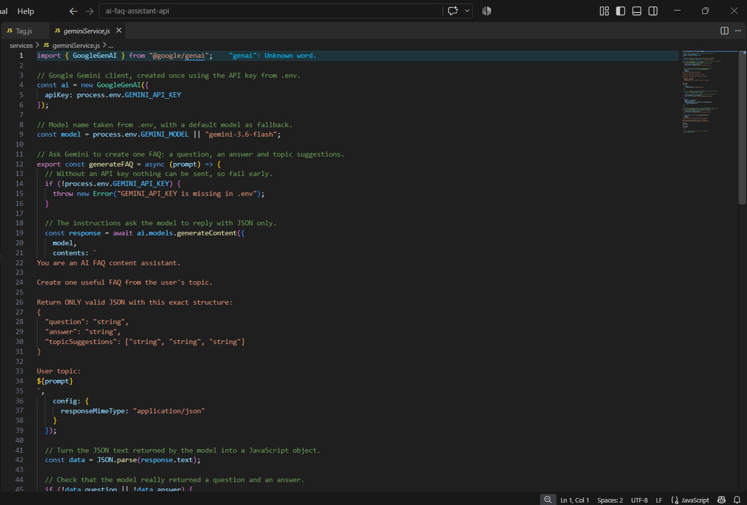
Figure 7. Gemini service implementation showing structured FAQ generation and generated answer processing.

10. Prompt Engineering Demonstration
The Gemini service uses structured prompts to request FAQ content in a predictable format. The generation prompt asks the model to return question, answer, and topic suggestions as JSON.
The AI answer feature also uses the supplied question together with FAQ context. The prompt instructs the model to avoid inventing facts when the available context is insufficient.
POST /api/ai/answer
The AI service is isolated in the service layer so that controller logic remains separate from Gemini-specific processing.
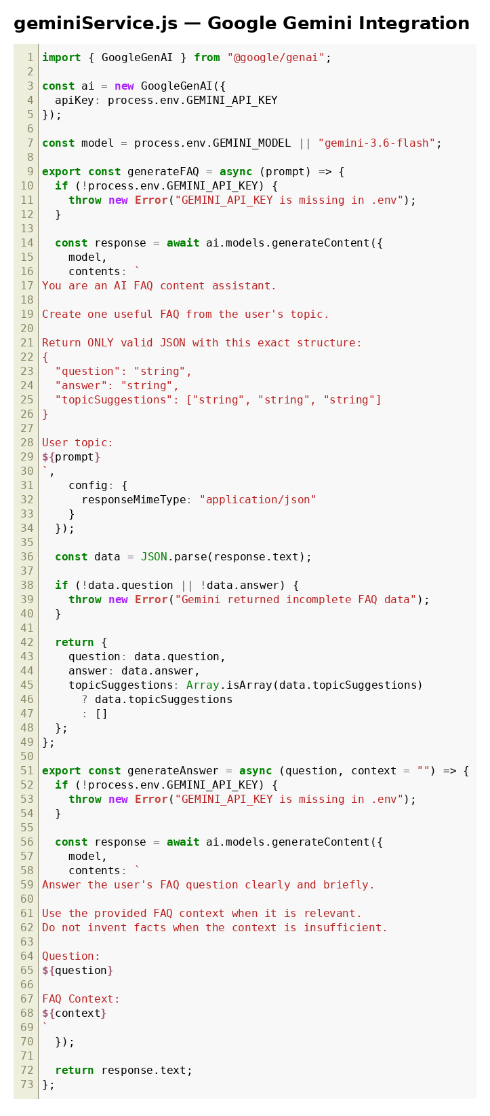
Figure 8. Gemini service showing the structured prompt and JSON-oriented response handling.
11. Search Demonstration
The current project provides keyword-based FAQ search. It does not implement MongoDB Atlas Search as a separate Atlas Search index.
GET /api/faqs/search?q=<search-term>
The search service:
• Restricts unauthenticated users to public FAQs.
• Allows authenticated users to access public FAQs and their own private FAQs.
• Searches question, answer, and tags using escaped keyword patterns.
• Returns populated category and user information.
• Sorts results using views and creation time and limits the result set.
The FAQ model also defines a MongoDB text index over question, answer, and tags. The current README explicitly describes the implemented search as keyword-based rather than vector search.
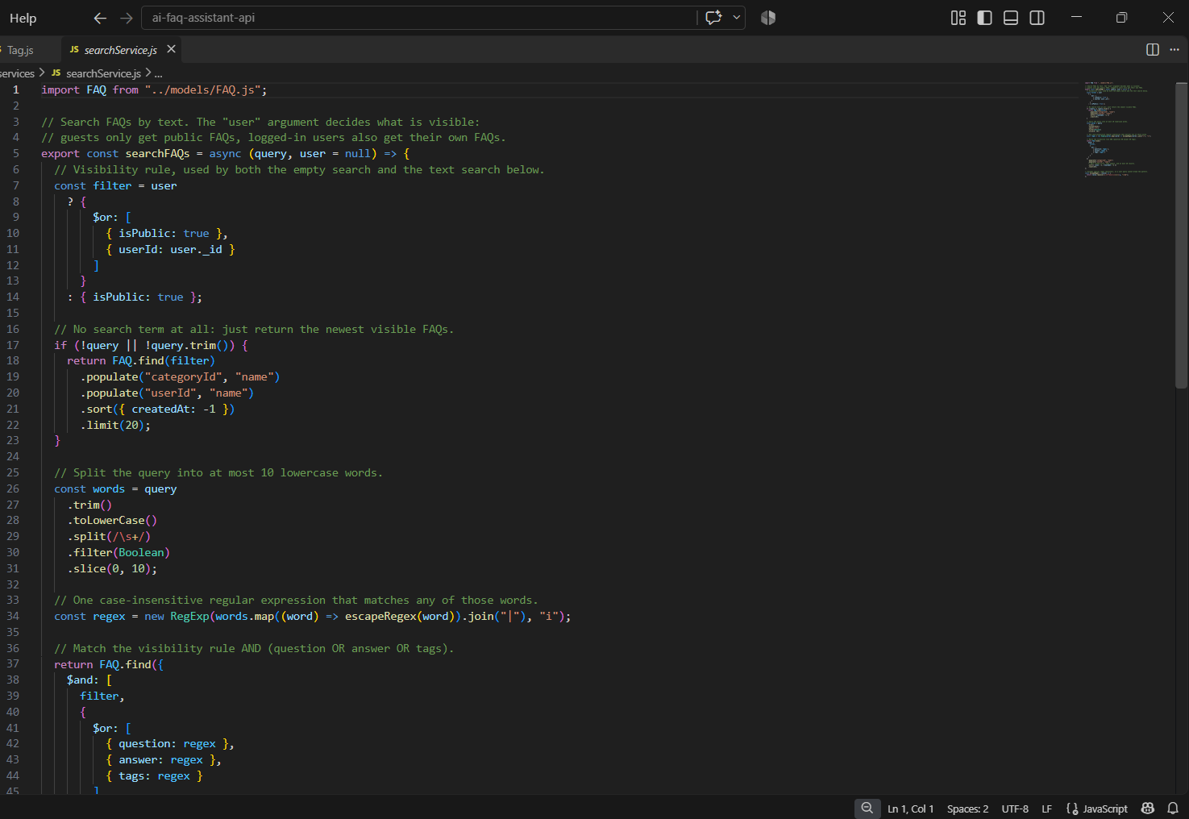
Figure 9. Search service implementation showing public/private FAQ visibility rules and keyword matching across question, answer, and tags.

12. AI-Assisted Answer Demonstration
The project includes an AI-assisted answer endpoint that combines FAQ context with Google Gemini.
POST /api/ai/answer
The controller first obtains relevant public FAQ context and then passes the question and context to the Gemini service. The generated response is returned to the authenticated user.
MongoDB Atlas Vector Search and embedding-based semantic search are not implemented in the current project source. Therefore, no Vector Search demonstration is claimed in this report.
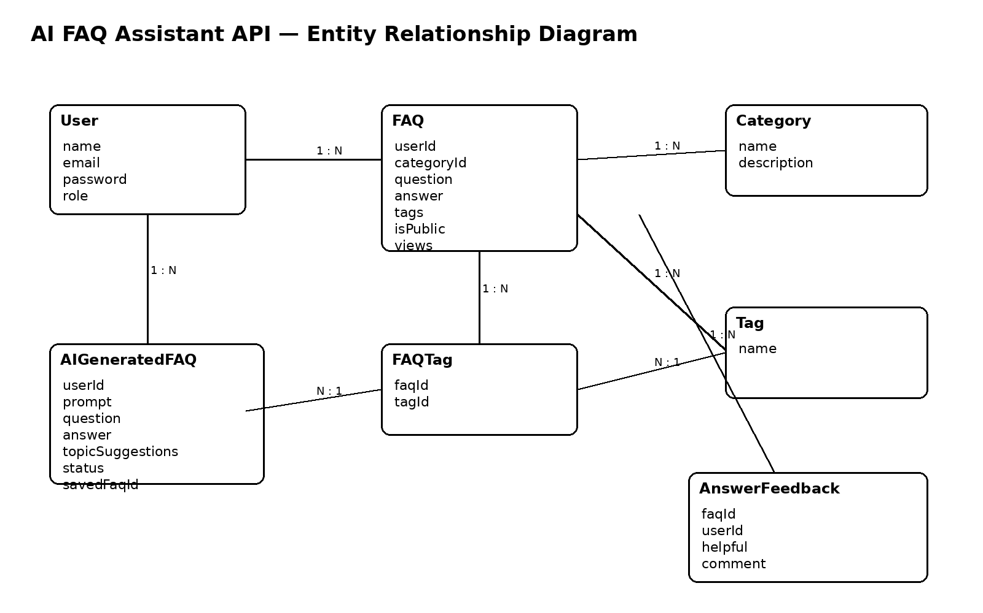
Figure 10. Database relationship diagram for users, FAQs, categories, tags, AI-generated FAQs, and feedback used by the current project.

13. Demonstration Outcome
The demonstration verifies the integrated operation of the AI FAQ Assistant backend. The following functionality is represented by the current implementation:
• User registration and login
• JWT-based protected access
• Role-based authorization
• FAQ management and ownership protection
• Category management
• FAQ feedback
• Google Gemini FAQ generation
• AI-assisted answer generation
• Keyword-based FAQ search
• MongoDB data storage and relationships
The API testing guide supplied with the project defines a broader sequence of endpoint checks. This report does not claim a fabricated pass/fail count; only results that are actually demonstrated or documented are described.
Confidential credentials, JWT tokens, API keys, and database connection strings are excluded from the demonstration report.

Conclusion
The AI FAQ Assistant API demonstrates a modular backend system that combines secure authentication, role-based authorization, FAQ and category management, feedback handling, keyword-based search, and Google Gemini AI services within an Express.js and MongoDB application.
The implementation separates routes, controllers, middleware, models, and services, making the major backend responsibilities easier to test and maintain.
The current demonstration reflects the features present in the project source. MongoDB Atlas Search and MongoDB Atlas Vector Search are not presented as implemented features because they are not part of the current project version.

